**IT8213 Data Centre management project**

|  |  |
| --- | --- |
| Semester: | Semester 02, 2017-2018 |
| Learning Outcomes Covered | The following learning outcomes will be tested:  1.Demonstrate a critical knowledge of Data Centre technologies  2.Utilize a scripting language to automate tasks and critically evaluate its implementation |
| Weighting: | 35% |
| Instructions: | * It is a group project. Each group may have up to 3 members |
| Due Date: | * Part A and C to be submitted in a Technical Document on Saturday June 23rd at 11:55pm * Part B to be submitted on Sunday April the 15th at 11.55pm |
| Submission: | * Electronic through Moodle |
| Late Submissions | * The School of ICT and Web Media Late submissions rules apply. * If an assessment is submitted late the maximum result the student can achieve is 60% in that assessment unless decided otherwise by the Head of School or delegate. * The cut off time for submitting an assessment will be 3 calendar days after the assessment is due. A student submitting after 3 calendar days will get 0%. * On application, course coordinators may approve extensions to deadlines for other forms of assessment, (such as projects and assignments,) up to a maximum of 2 calendar days. Applications must be made before the stated deadline. |

**PART A (12.5 marks, LO1)**

A Ministry in Bahrain has been informed about the new Cloud first policy published by the eGovernment in 2017. The Ministry wants to investigate how to migrate all future and some existing applications to the Cloud from 2018. The current Data Centre infrastructure in the Ministry is 6 years old and nearly all devices need to be upgraded at the end of 2018. The Ministry also has an offsite disaster recovery Data Centre where backups are stored at the end of each working day. Instead of using the disaster recovery Data Centre the Ministry wants to investigate using the Cloud to perform this task. The Ministry keeps in its database information about each citizen in Bahrain including their CPR, financial information and health information. This data is sensitive so security is very important to the organization. The Manager of the ICT department is nervous about moving many of the applications to the Cloud due to security concerns. The current Data Centre is ISO27001, PCI DSS Level 1 and HIPAA compliant.

You are required to;

Compare Cloud vs Physical approach to implementing a Data Centre. The current Data Centre that houses the old equipment is a large telecommunications room of 500 square feet with 16 racks and 10Kw of power per rack. The discussion should cover areas such as cost, security, compliance, redundancy and availability in the comparison. The students should make a final recommendation on which option is the best to use.

Note: The Physical equipment maximum specifications are only needed for one week a year. For the remainder of the year 20% of the maximum capacity is used on average.

During this discussion you should critically discuss the difference between the two Data Centre options. To critically discuss you will need to read a number of journals, textbooks, magazine articles and web resources and quote from these articles. At least 15 references should be used in this discussion. The discussion should be between 3500 to 4000 words long. The students should show relating and reasoning in their critical discussion. Figure 1 discusses what relating and reasoning are. 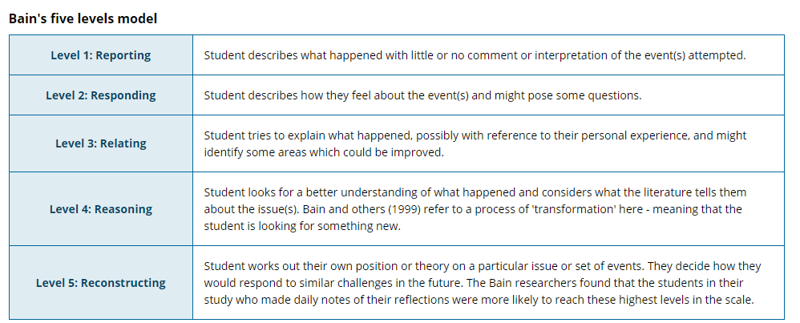

Figure 1: You must use relating and reasoning in your critical discussion.

Resources:

1. The AWS calculator should enable you to calculate costs on the Cloud. <https://calculator.s3.amazonaws.com/index.html>
2. The attached file will give you the costing of the Data Centre equipment that is needed to fit the requirement. The processing power that is purchased is to meet peak demand on 3 days a year. It is envisaged that demand will be on average 20% of this load for the remainder of the year.



1. Example of prices and operational cost of Data Centre vary depending on size. You may use prices from other country’s to do the analysis. Example <https://www.365datacenters.com/portfolio-items/data-center-colocation-build-vs-buy/>

**PART B (10 marks, LO2)**

The Ministries current Data Centre needs to be monitored.The Server at IP address 104.236.166.95 holds all of the main applications of the Ministries Data Center. The uptime of this server is very important as it runs a number of the main applications of the company including the eCommerce website which accounts for 80% of the Ministries revenue. The ICT Manager has requested that an automated email be sent each day at 2pm about the following issues to see if the hardware needs to be upgraded.

1. Total RAM used on server and the percentage of overall RAM that is used.
2. Percentage of CPU that on average is being used.
3. The 15 minute load on the CPU.
4. There should also be an automated email sent if the RAM or CPU utilization reaches over 70%
5. All of the information should be logged in CSV format in a log file for auditing purposes.
6. There should also be a graph of the performance of the CPU and RAM statistics created. These files should be attached to the email.

**Python Modules to assist you**

These exercises will be completed using the following Python modules

1. pySNMP
2. smtplib including email utils
3. matplotlib or other graphing package
4. Library module should be used for storage of data.

**Part B Deliverables**

You need to include a 1,000 word report explaining how the modules have been used to implement the problem under investigation. In this section, you should also explain about, SNMP, its main features and how it is used in the project. The code required should be uploaded to Moodle.

**PART C (12.5 marks, LO2)**

In moving a lot of the current infrastructure to the Cloud the IT team is looking to use automation techniques listed below to do this; You should implement 3 working examples from the following list,

* Ansible
* Jenkins
* GitHub
* Nagios
* AWS

The solutions should be different to those that have been introduced to in class. You are required to present an implementation to your tutors that will show how each of the above can be used for automation. You must demonstrate that you have got each of the automation techniques to work to your tutor during the assessment week. Example use cases for the implementations of each of the Automation techniques is described below. You are also able to change the use cases if you are able to find a different scenario that tests automation for the technology listed.

1. The use of the BOTO3 python module to allow for the backing up of data on AWS
2. The use of Ansible to implement a Web Framework onto a remote server and also to configure Networking devices remotely.
3. As a system administrator it is your job to upload any changes to the eCommerce site to the server. This process is to be automated using Github and Jenkins servers and these changes will be done automatically and the changes should be uploaded to the Cloud.
4. The use of Nagios as an application monitoring tool to monitor performance should also be implemented.

Each technique should have a 400 word discussion along with 6 screenshots to show how you have used the above tools. There should be a 500 word critical discussion on using scripting and automation and how their role is going to impact on jobs in future years. You must use 10 references here at least.